**Securing Azure Functions App using**

**App registration**

**The steps to secure an Azure Functions App using App registration are as follows:**

* Create an app registration.

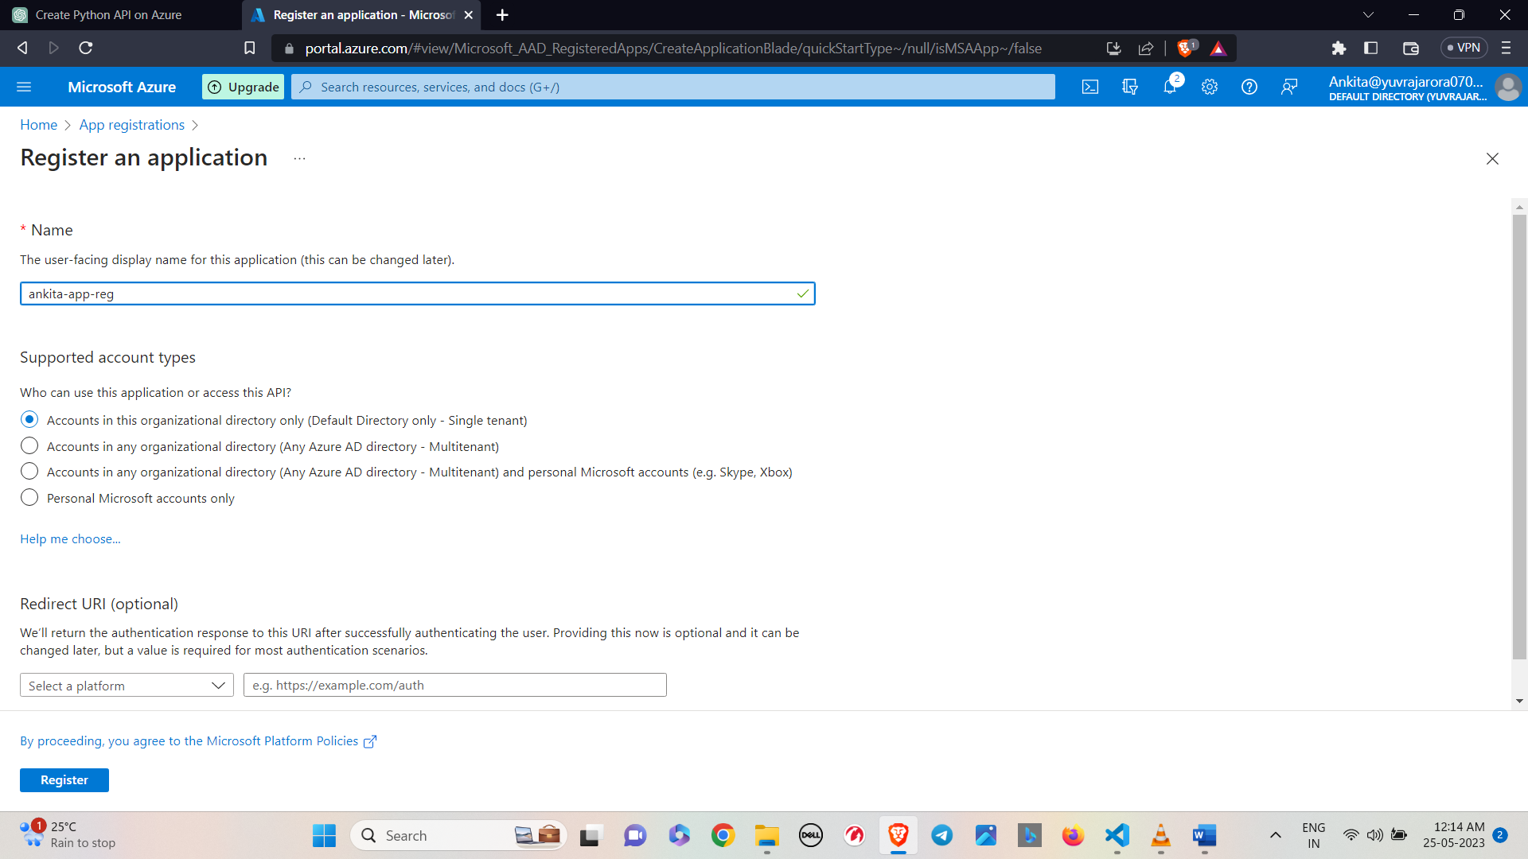

* After creating it you can check your app registration at all applications

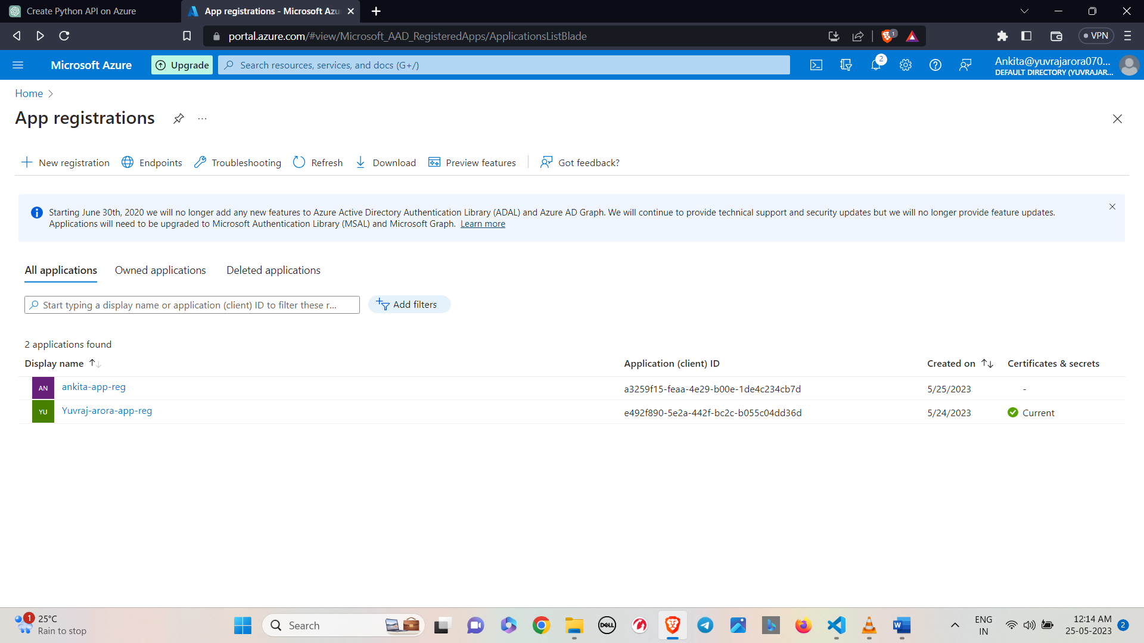

* If you click on your app registration you will see all details about your app registration

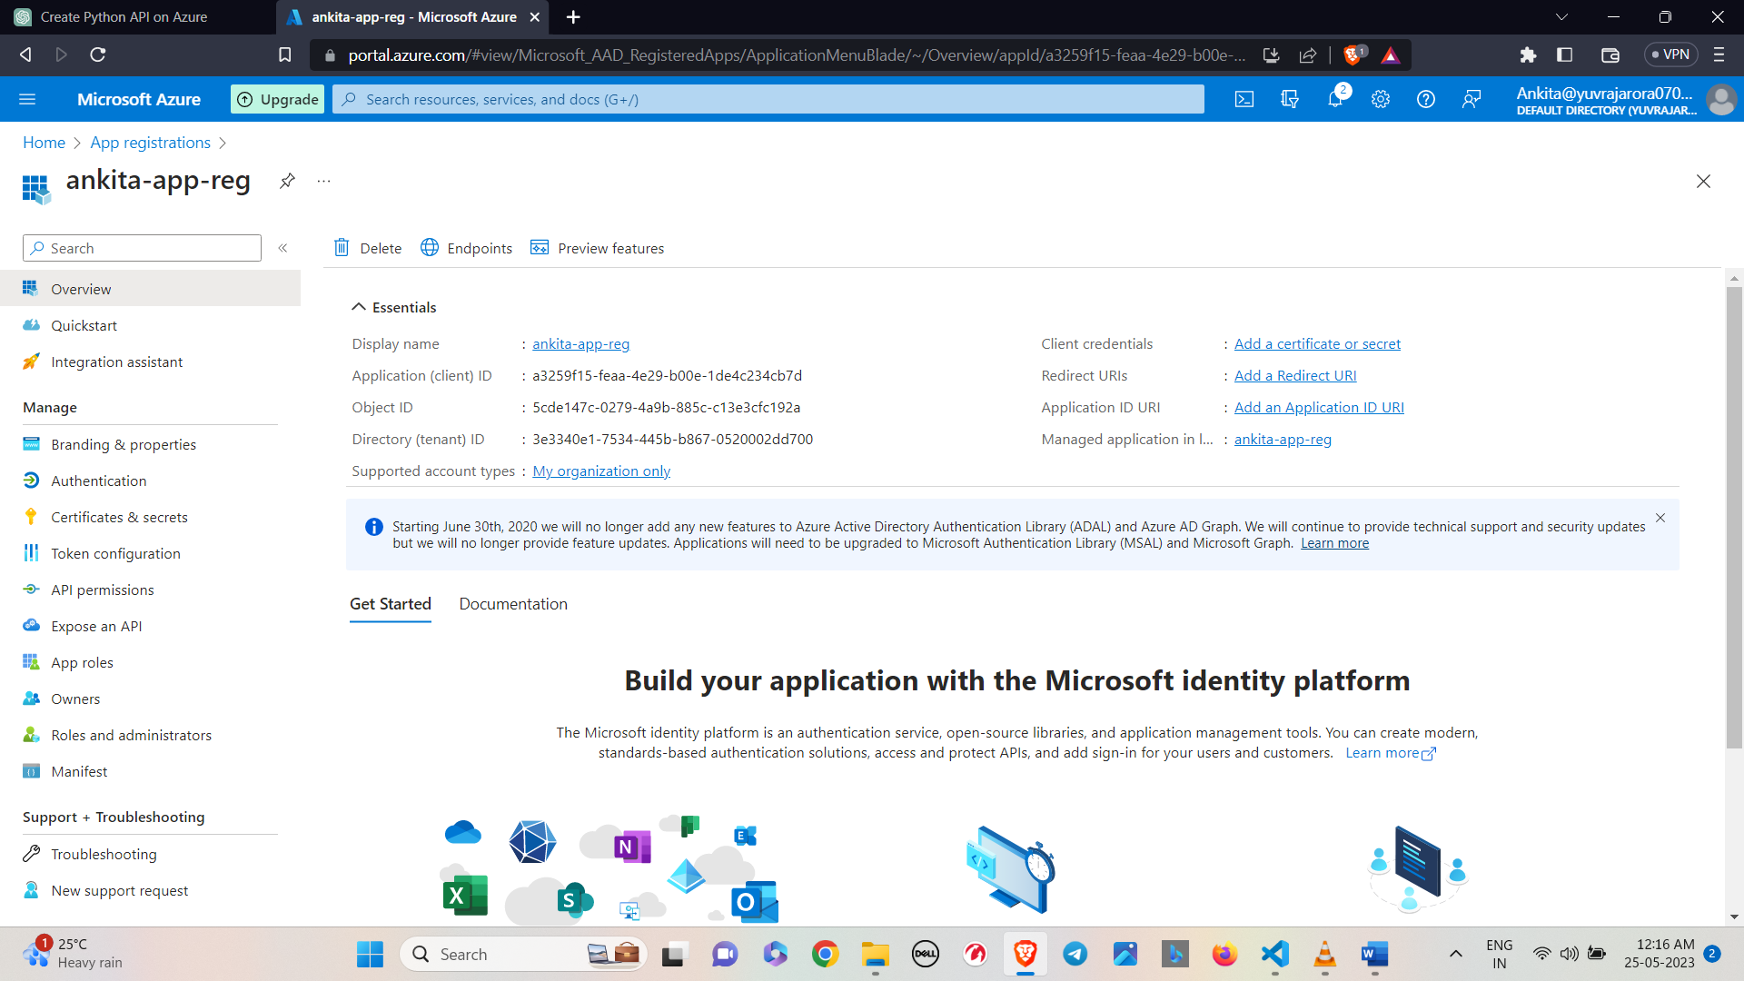

* Click on certificates and secret.

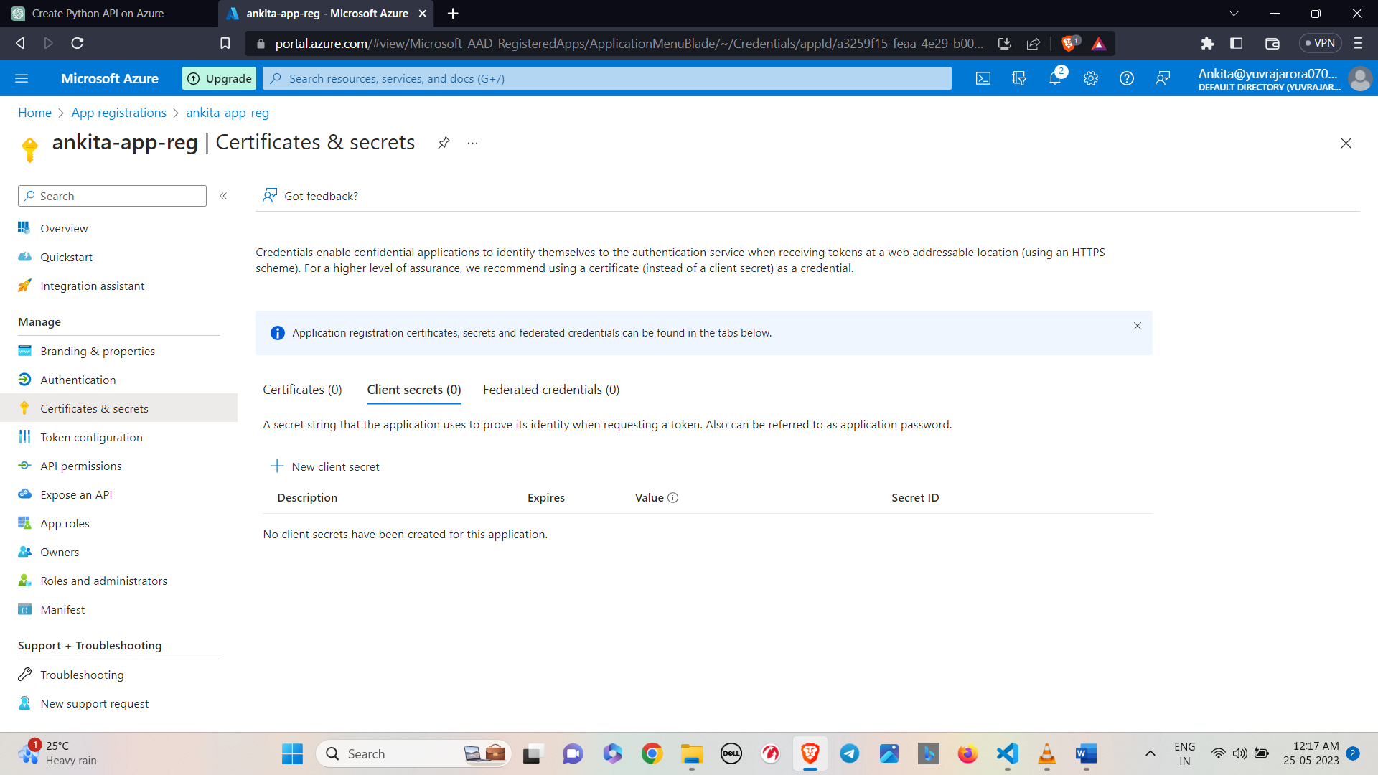

* Create a secret by clicking on new client secret.

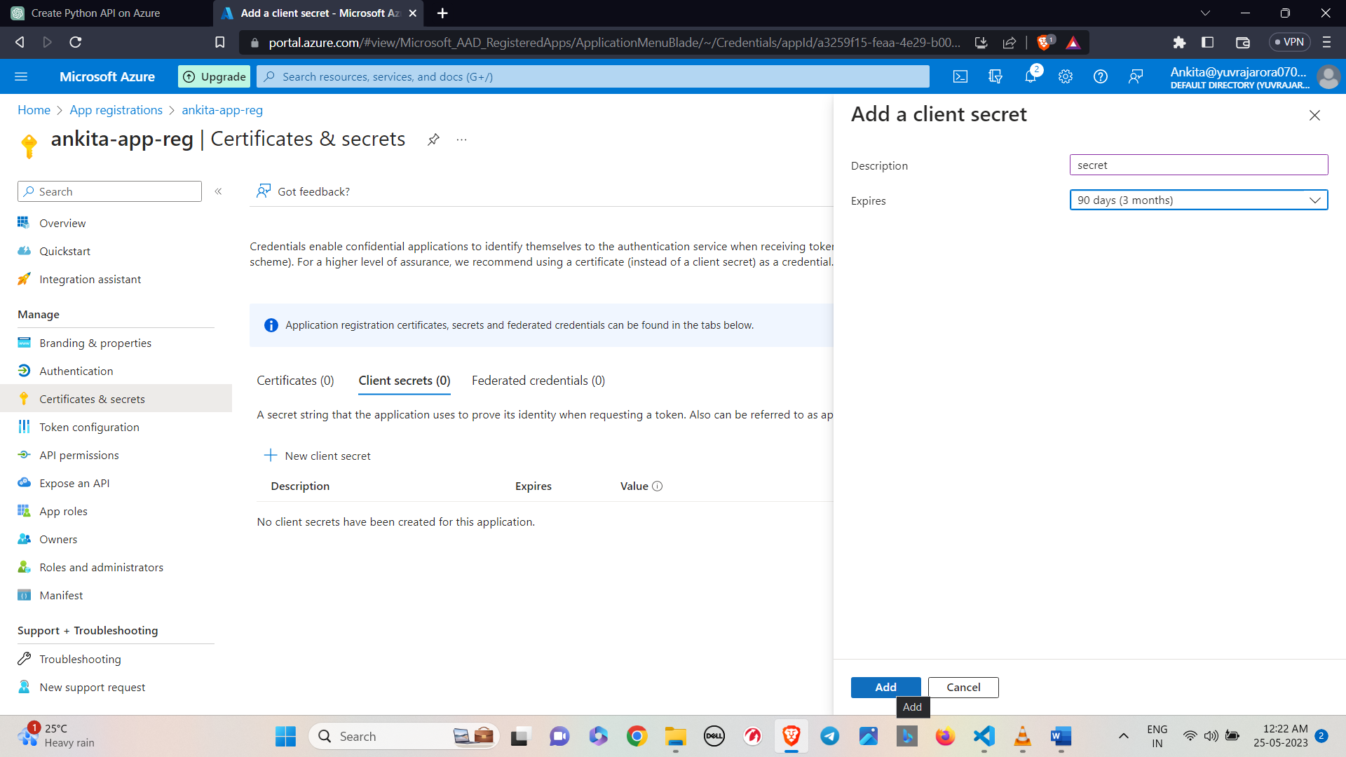

* Now secret has been created.

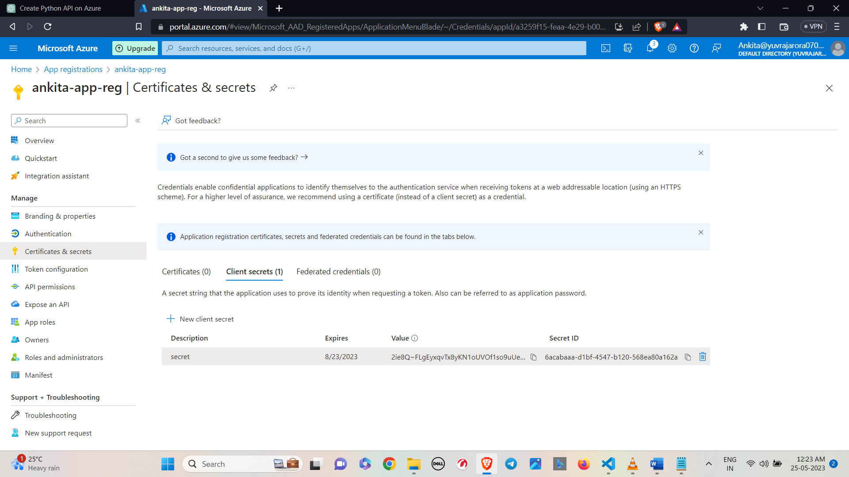

* Create a function app via VS Code.
* Click on the Azure extension on the side bar.
* Select the WORKSPACE tab and click on the new function button.

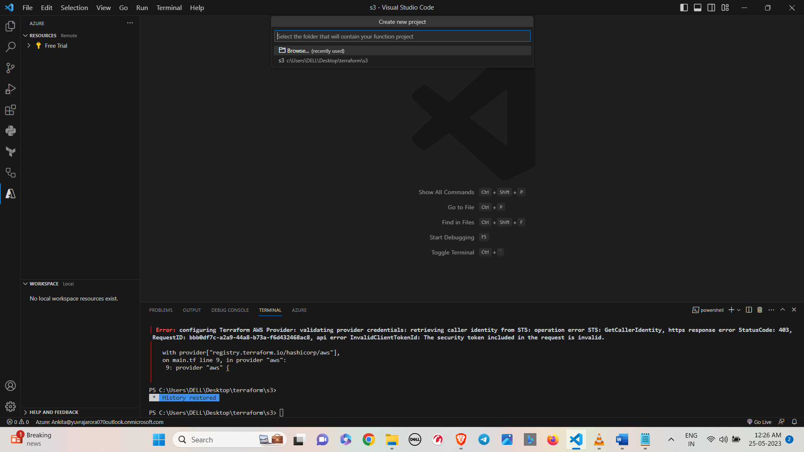

• Select the language you want to code in.

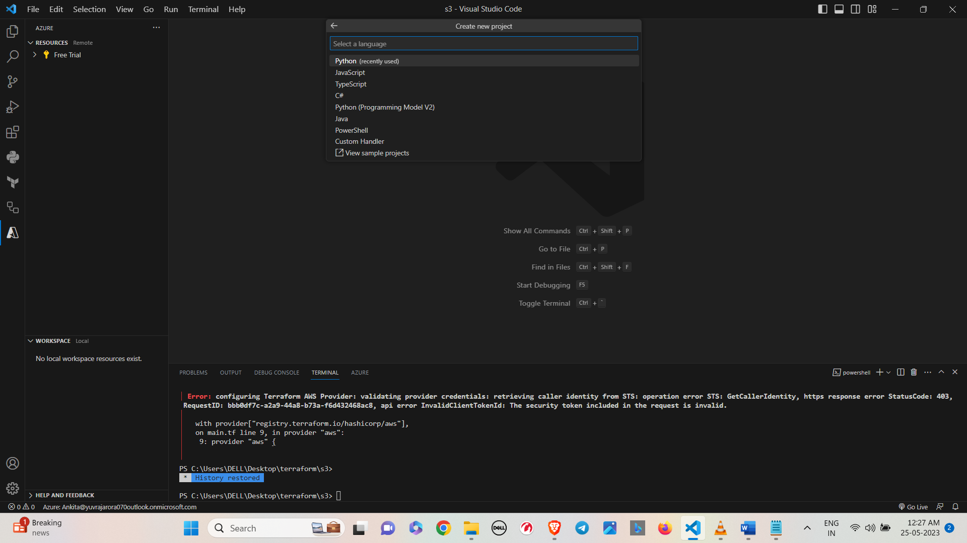

• Select the Interpreter for the virtual environment.

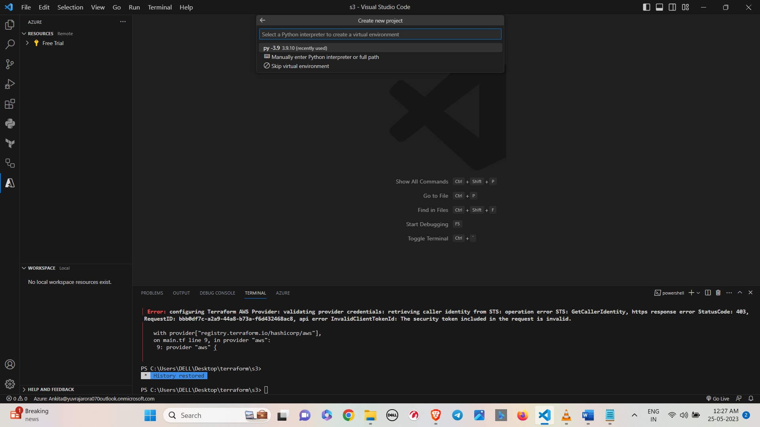

• Select the template for the function. Here we are selecting HTTP Trigger.

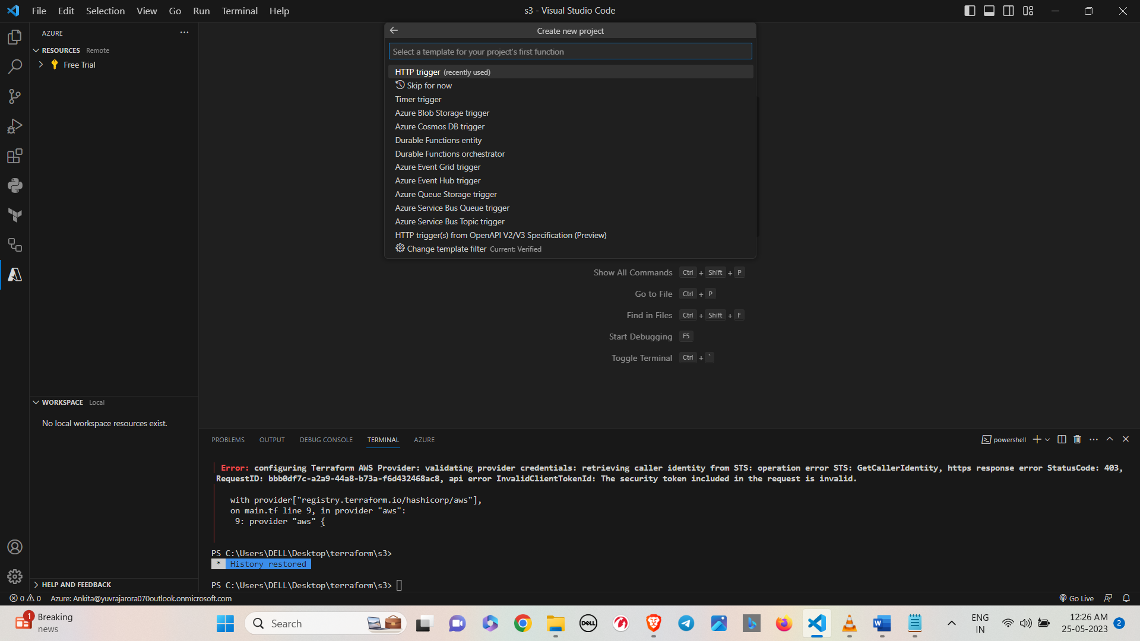

• Provide the name of the function.

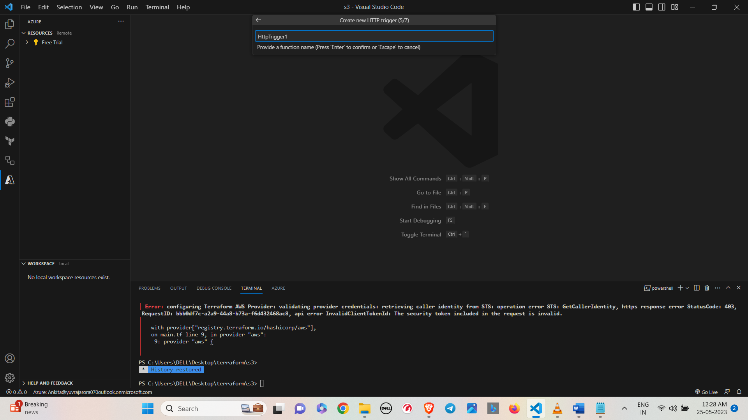

* Select anonymous.

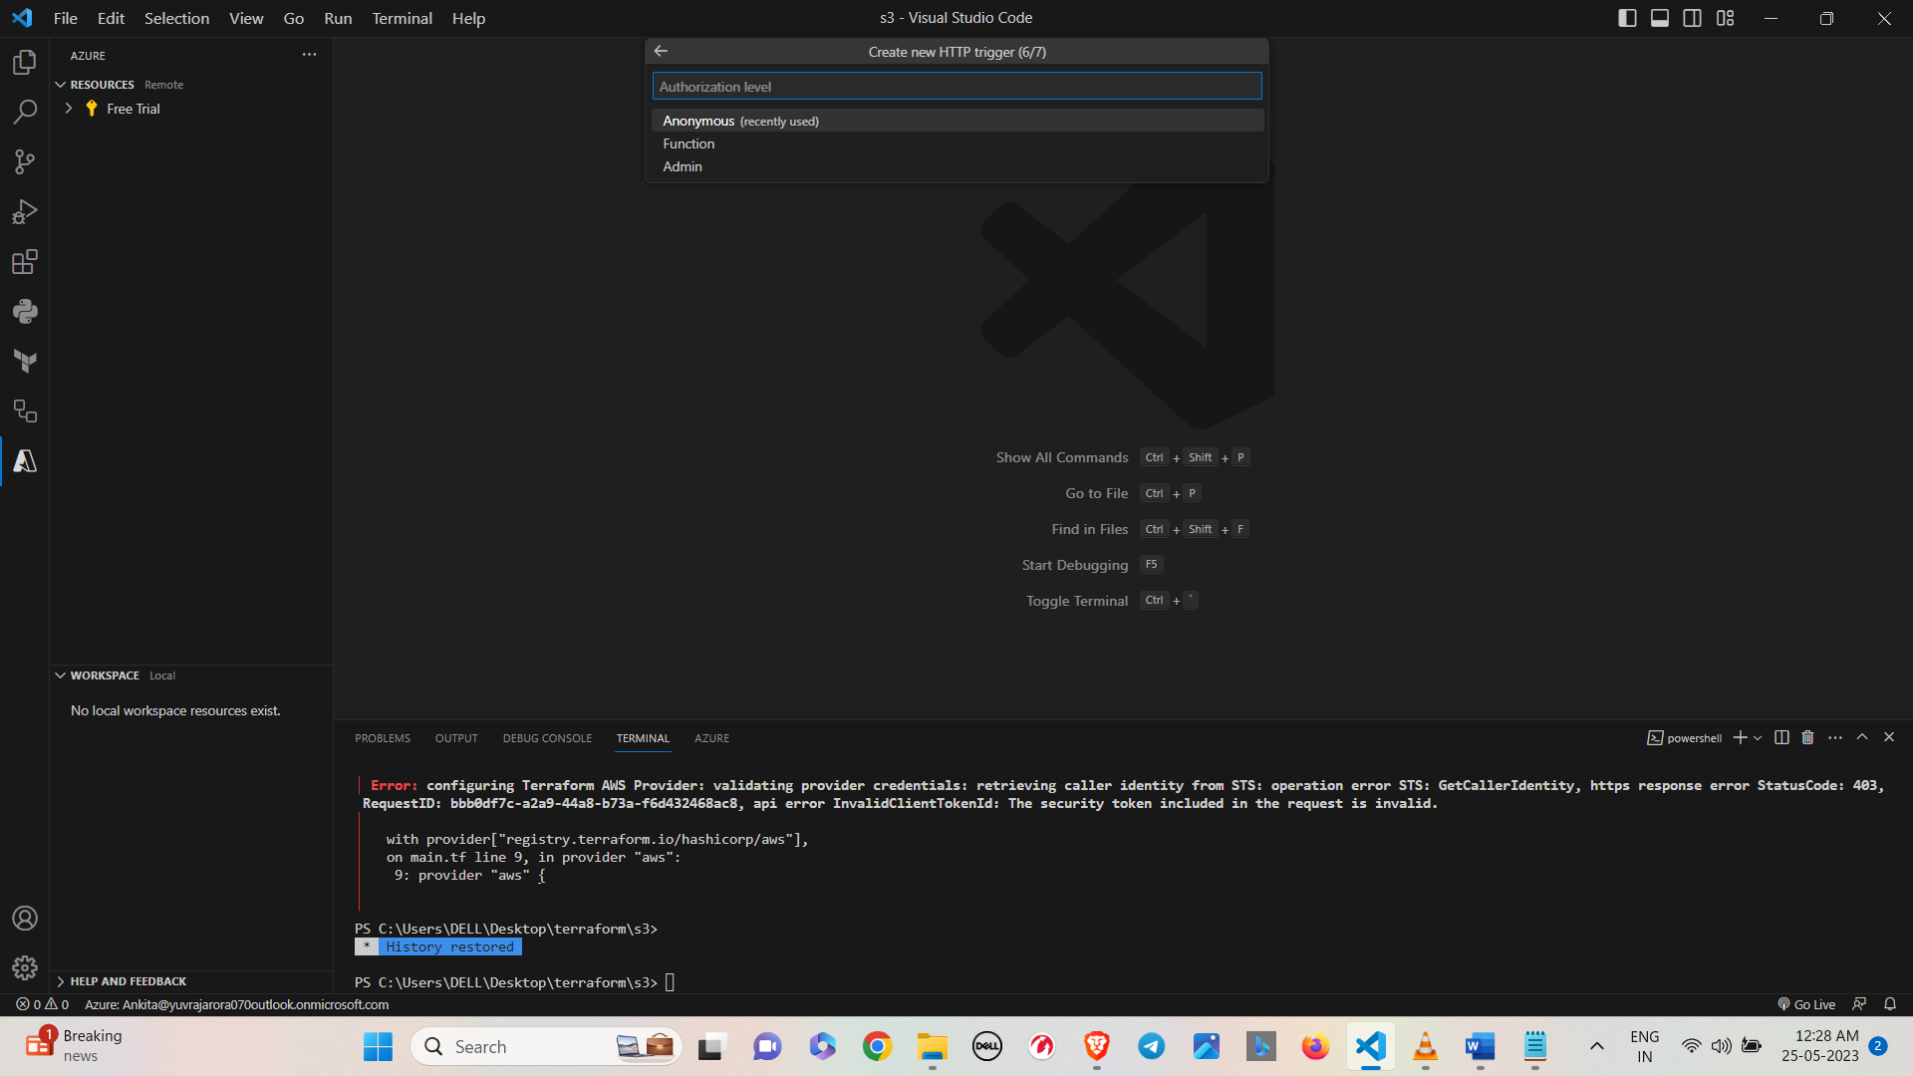

• The function project will be created on the local machine.

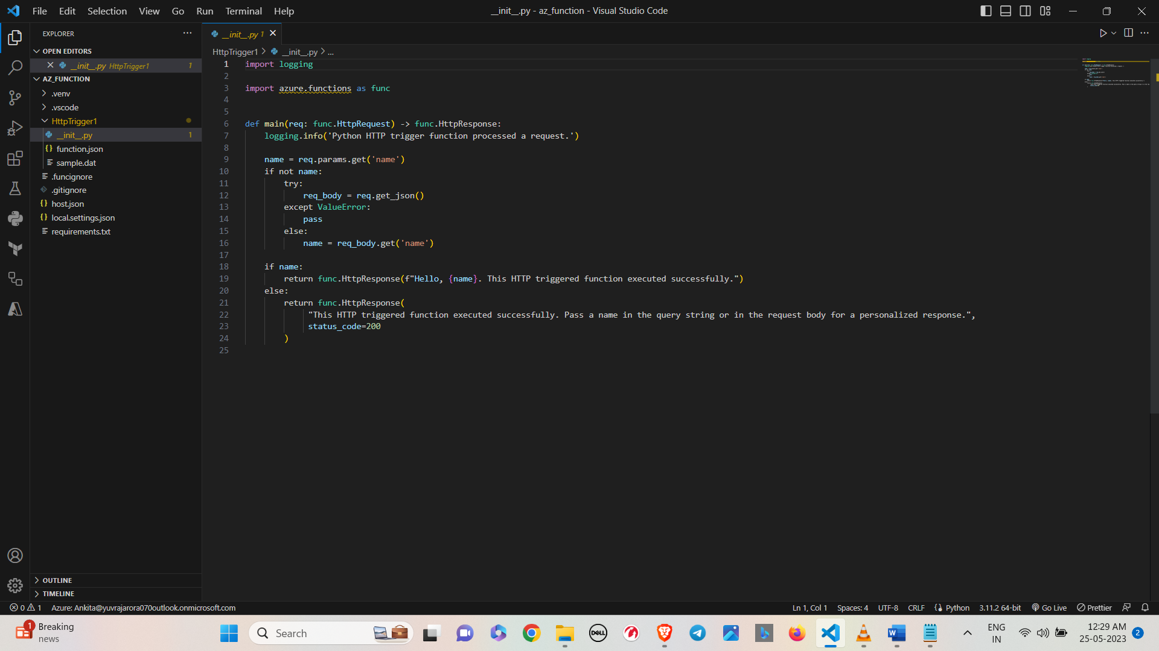

* Create the Function App.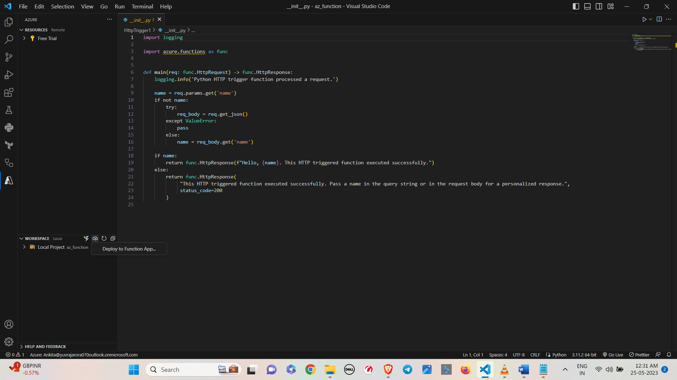

• Provide a unique name to the function app.

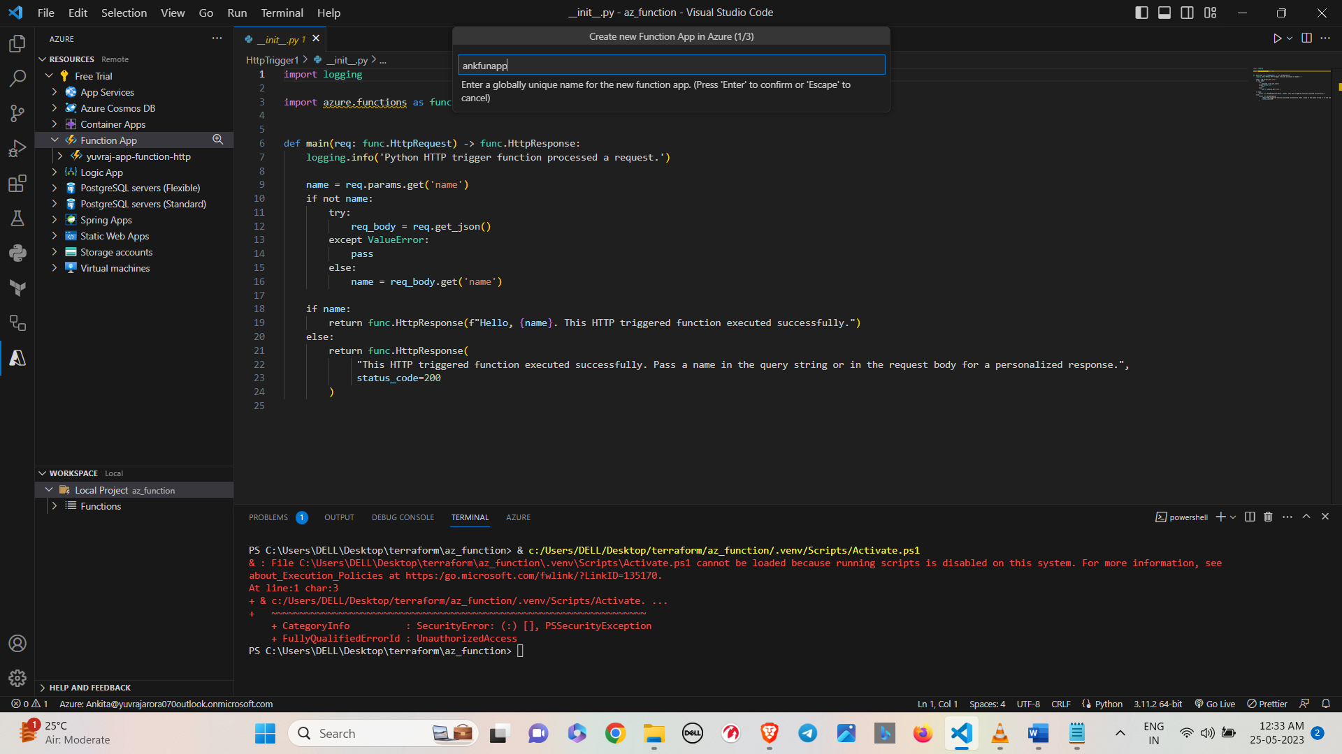

• Select the runtime for the function

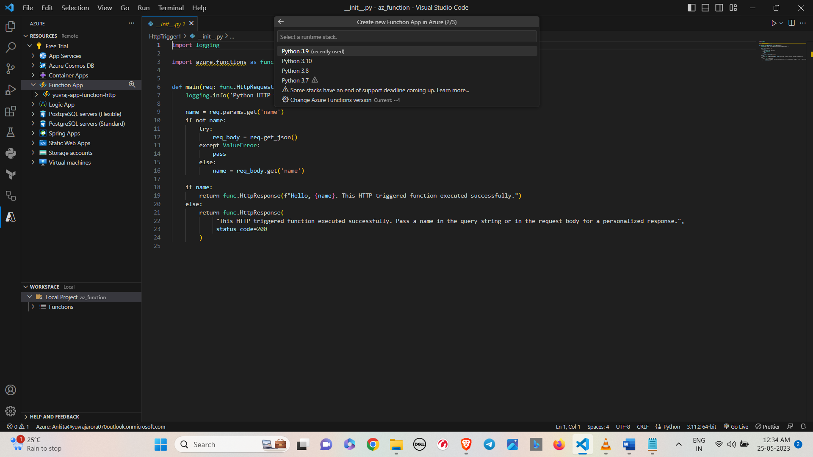

• The function app has been created.

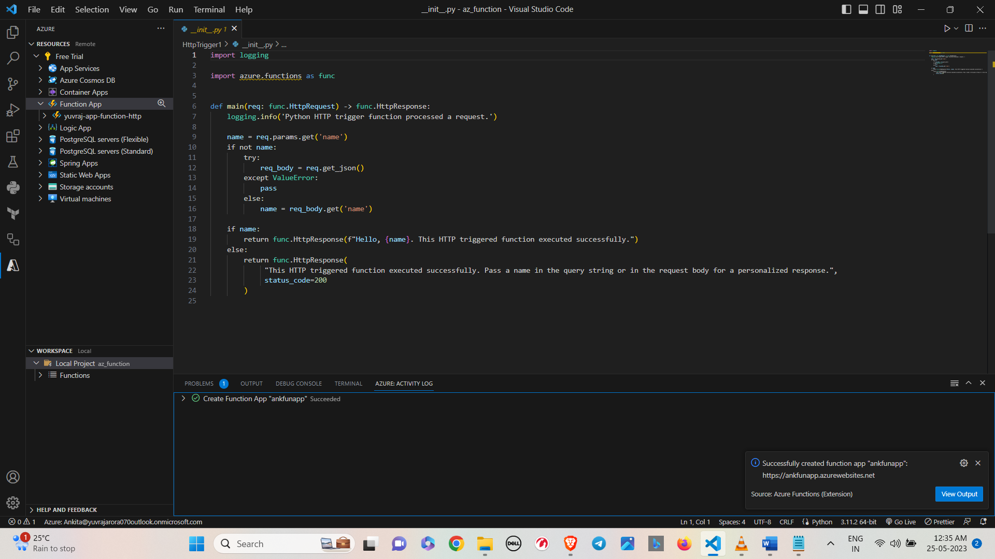

• Select Deploy on the prompt.

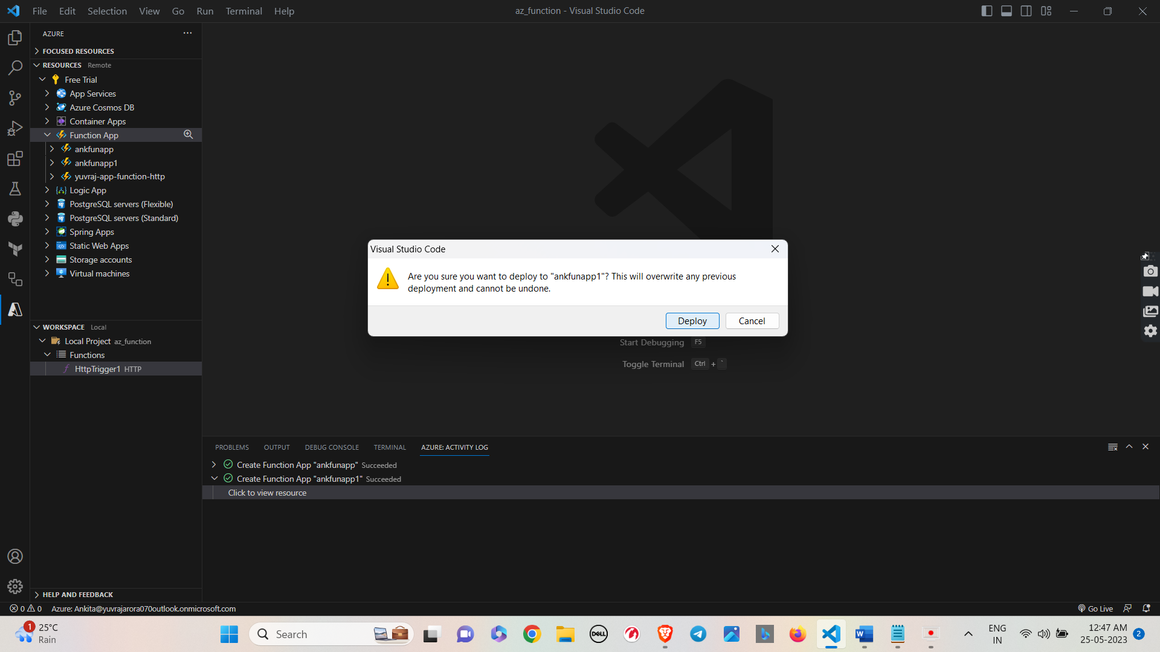

• The function will be deployed in the Function App.

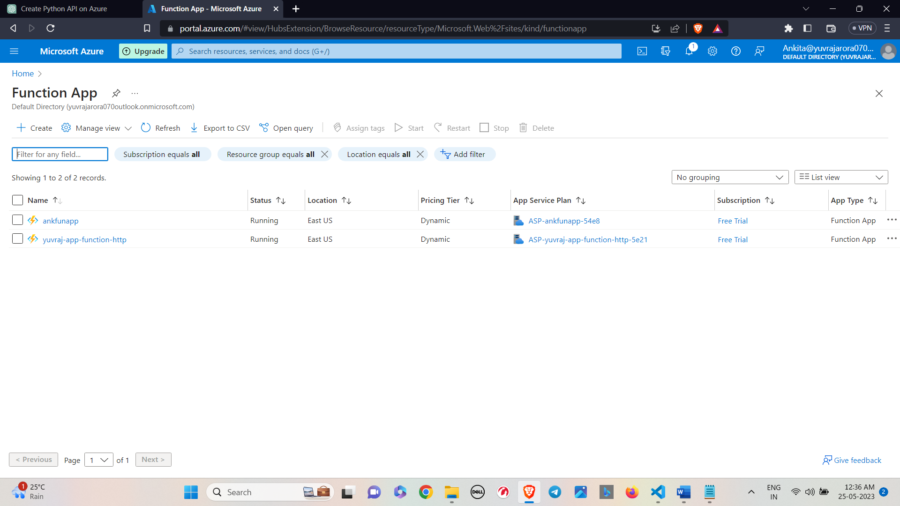

* Now click on your function app.

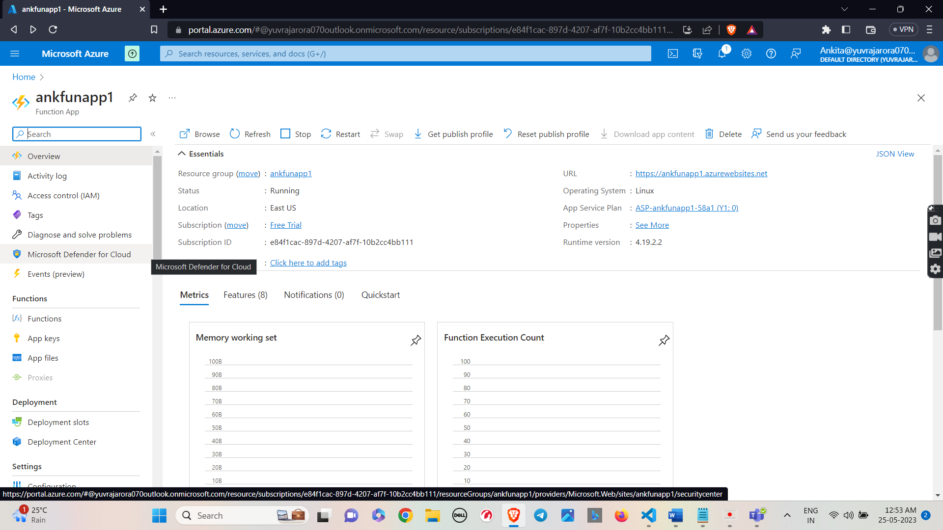

* Now here you can see your http trigger inside your function app.

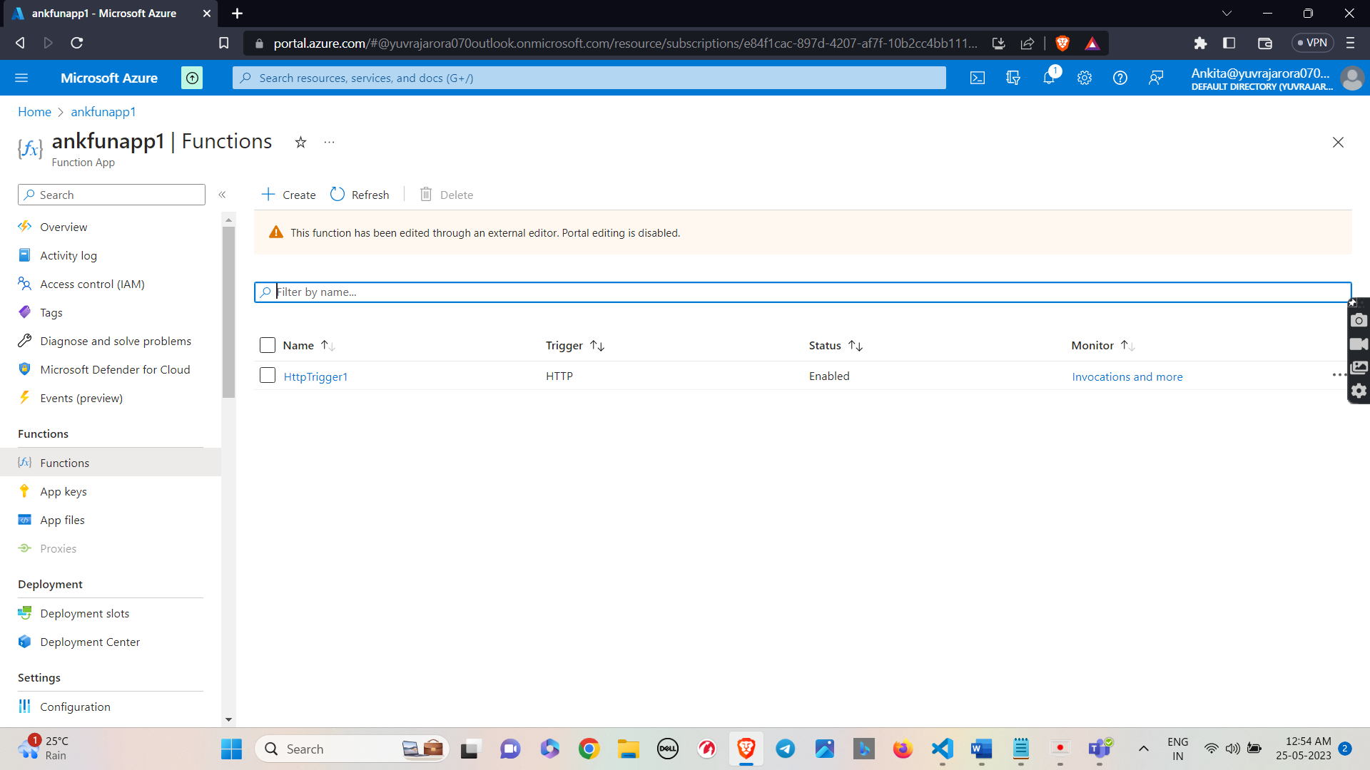

* Now click on HTTP Trigger.

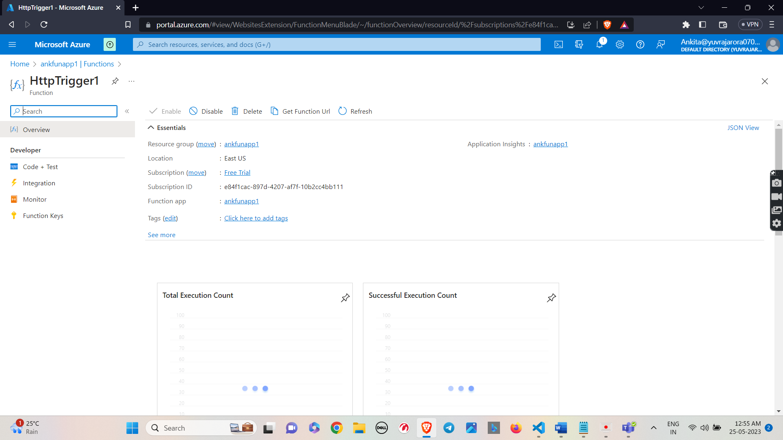

* Copy the URL of the trigger and browse it and you will be able to access your trigger.

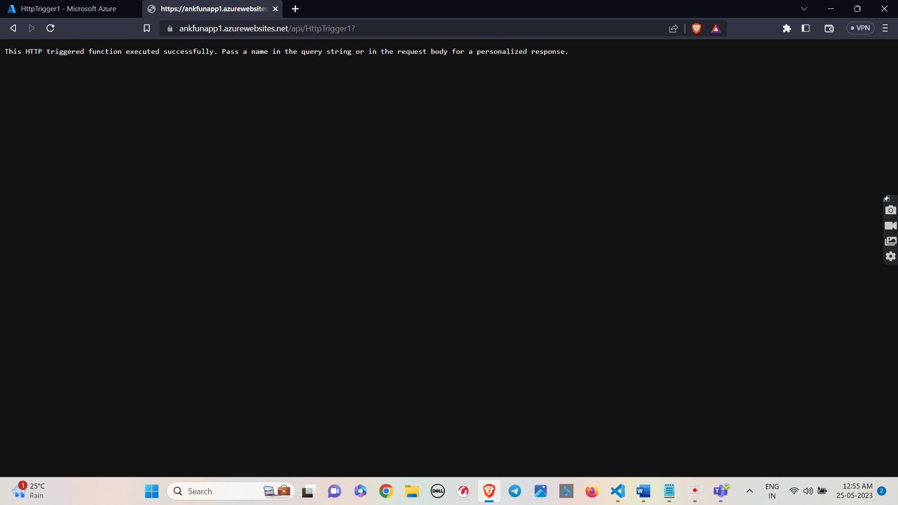

* Now to secure it and we will move further.
* Now go to your function app and on LHS search for authentications and click on authentications.

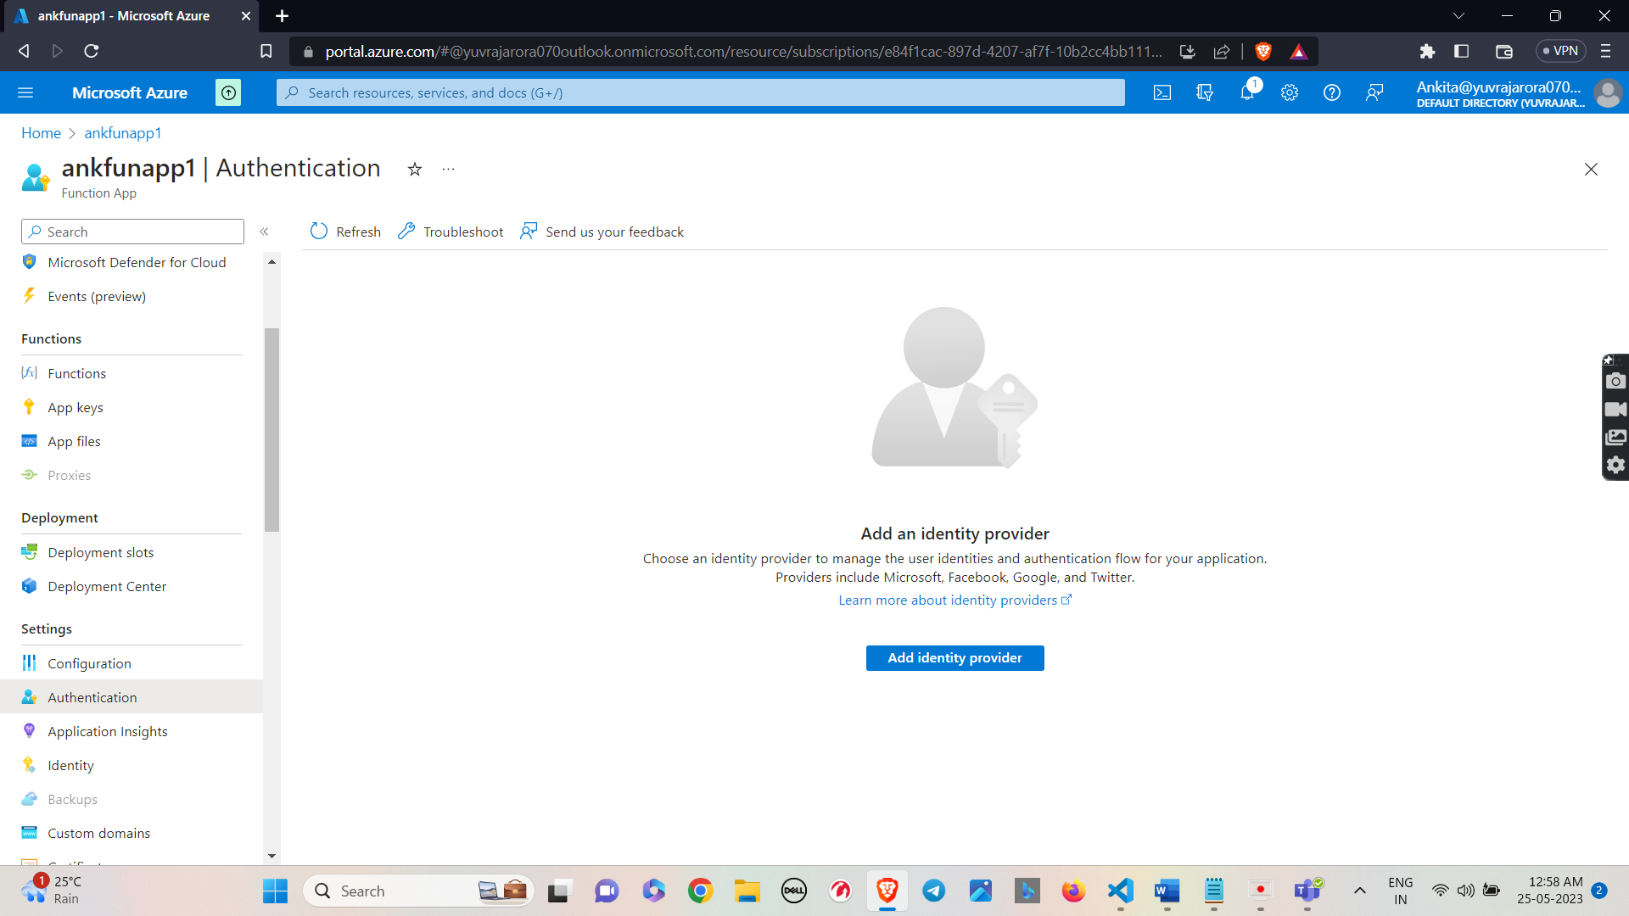

* Now add a provider

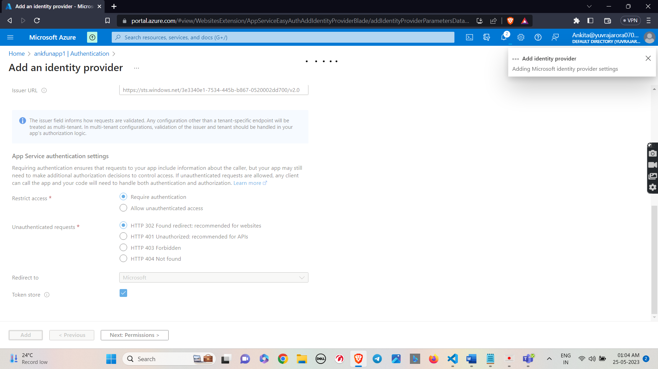

* Information about the authentication is shown.

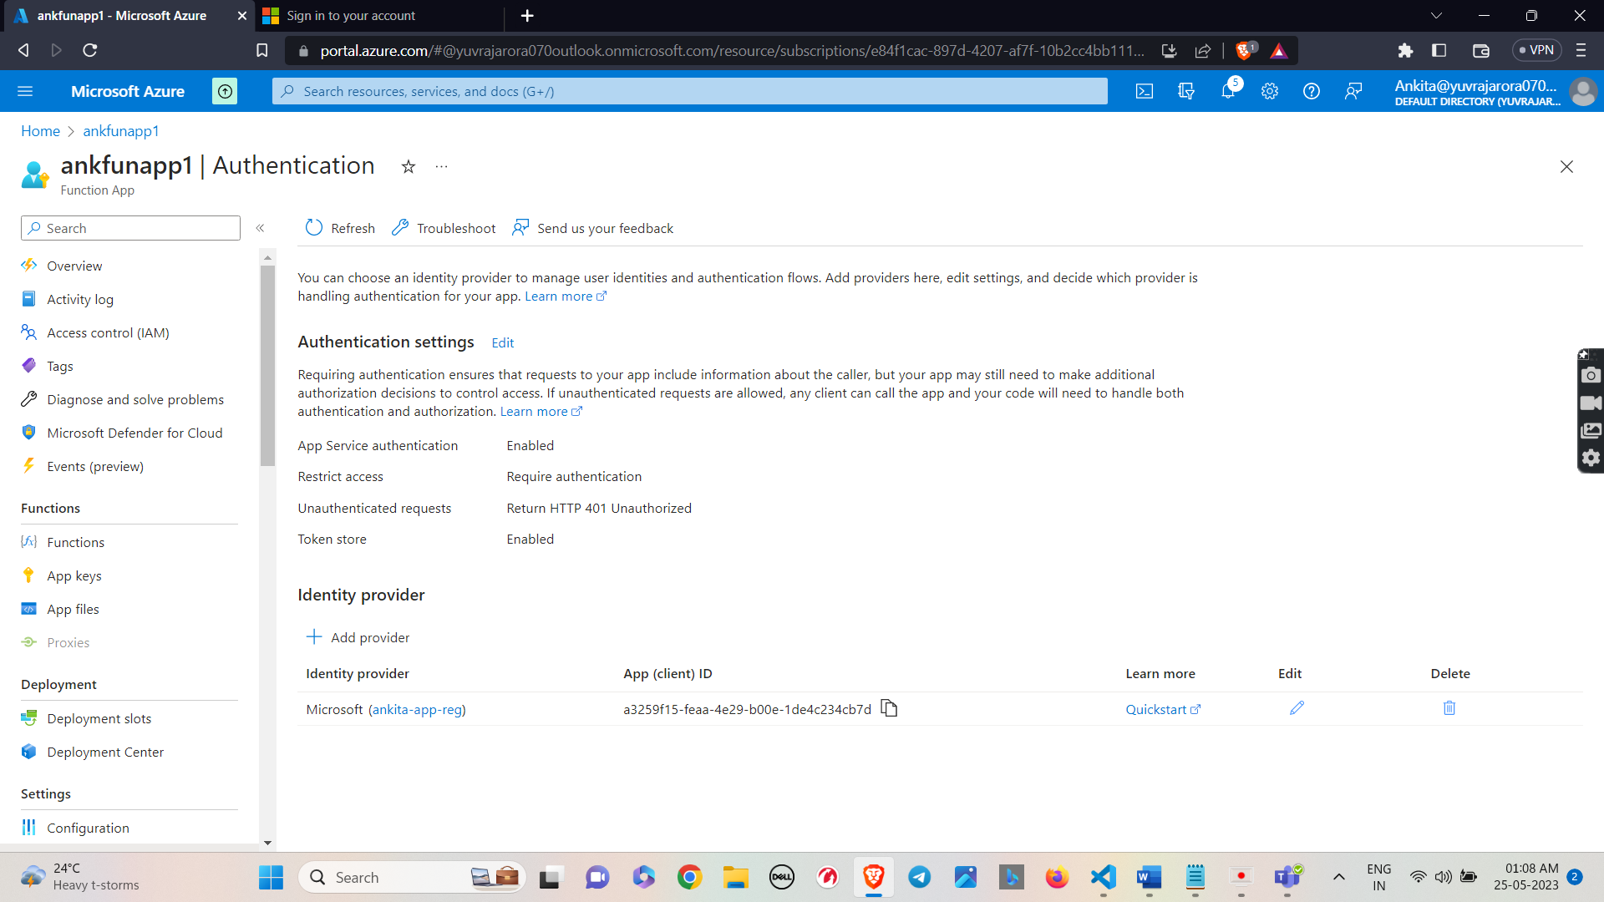

* Now after authentication you are not able to access the trigger.

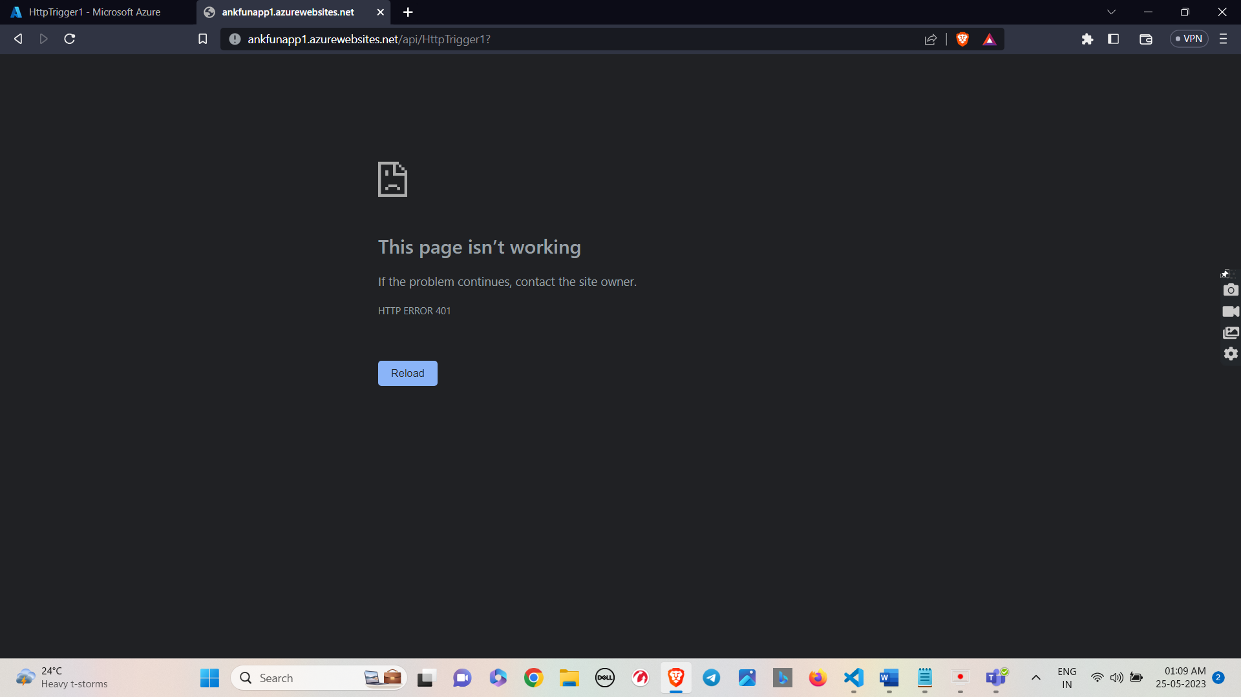

* Now to access the trigger we will use postman.
* Getting the token for accessing the Secured Function App.

* Now we must add certain parameters in Postman app to get the access token from Microsoft.
* Paste this link in the Postman app and replace the ClientID with the Client ID of the App registration.
* Now click on Body and now we will enter the ClientID and the Secret value of the App registration.
* Now click on send button.
* Now token has been generated. copy the token .

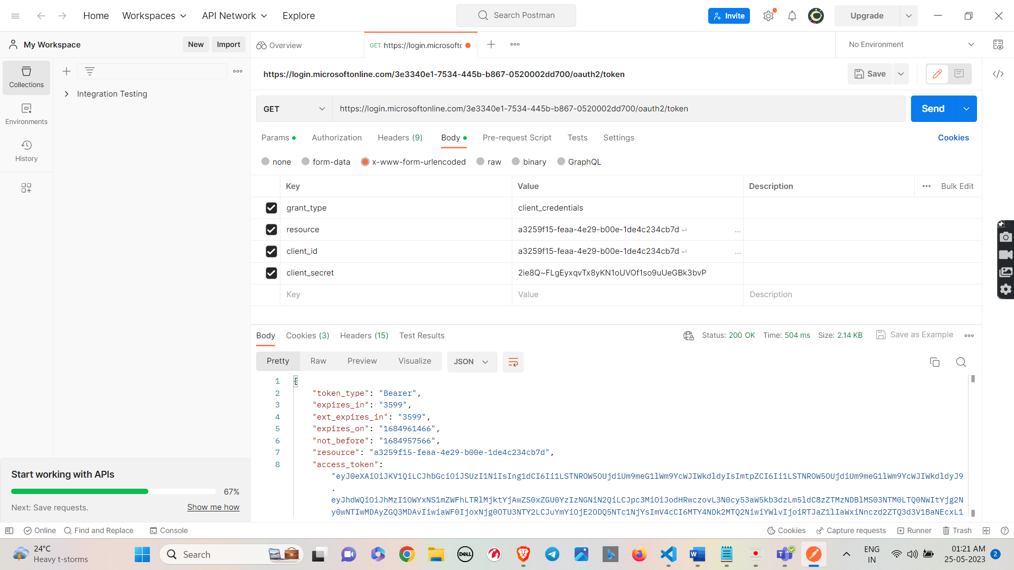

* Now past the URL of http trigger and moving further select authorization and select bearer token from the dropdown and copy the token. Click on send.

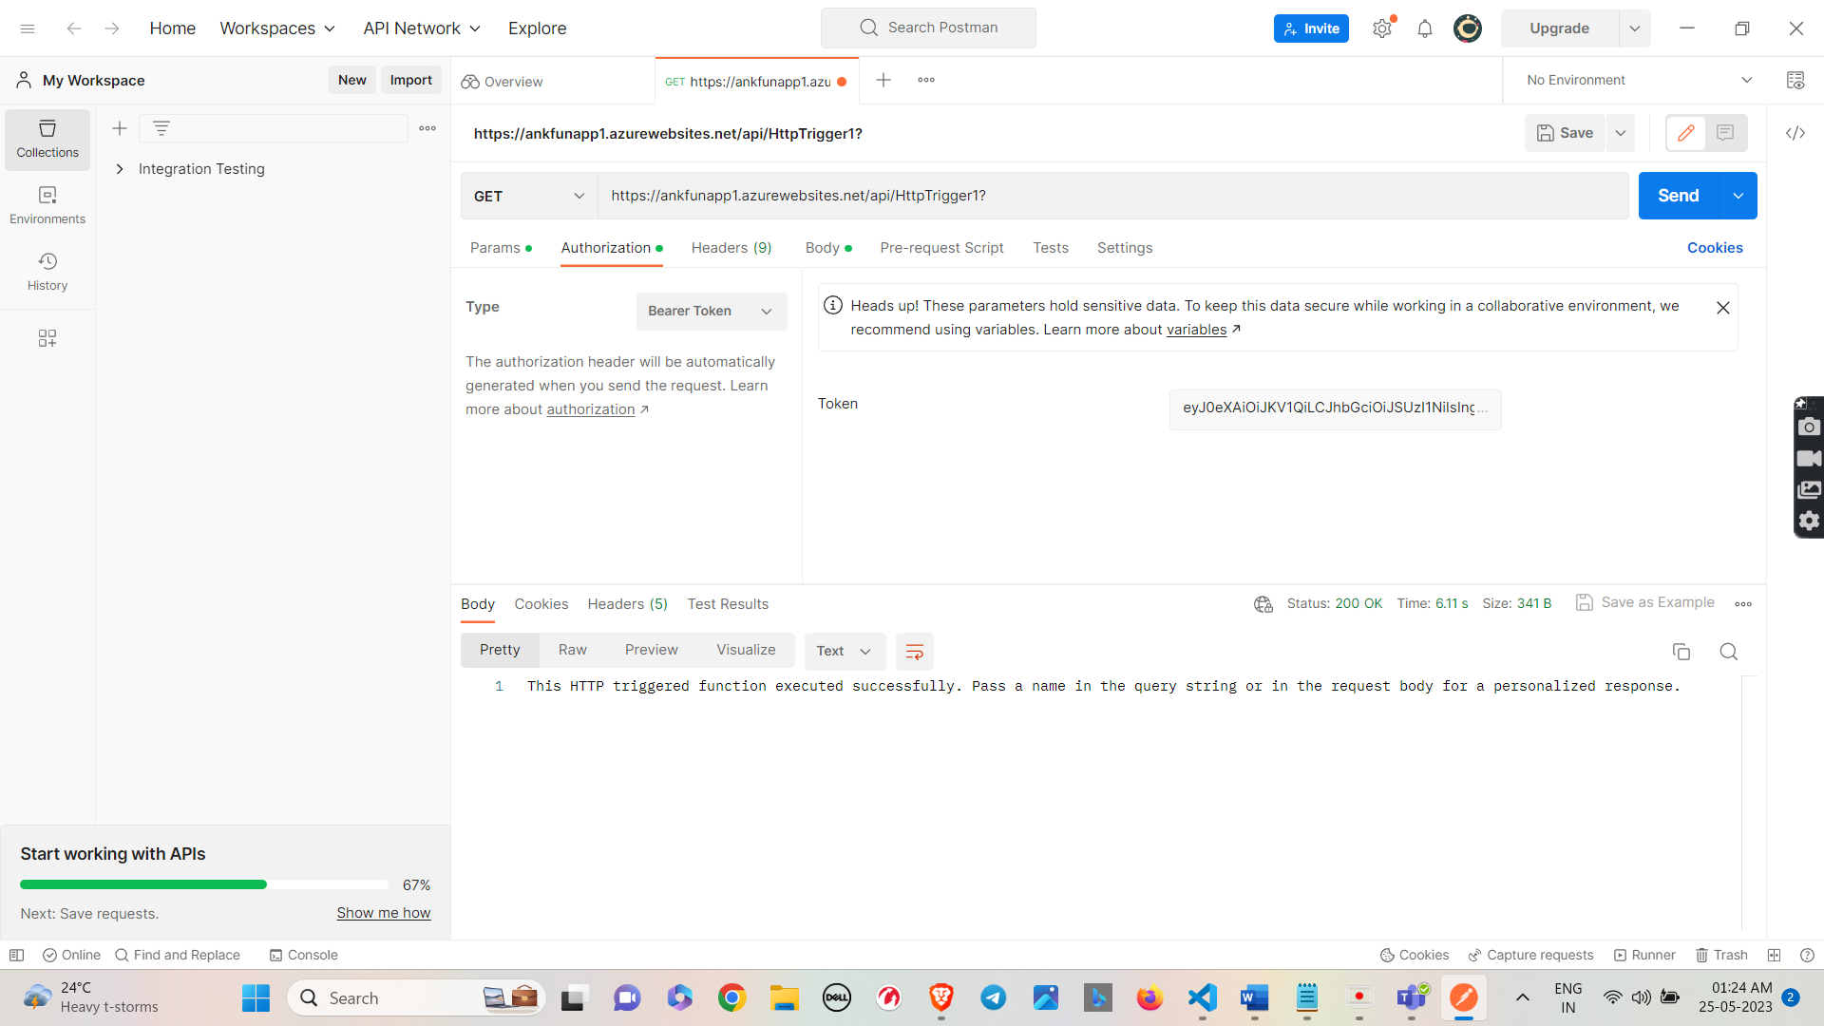

* Now here HTTP Trigger has been triggered and message provided inside the logic of the HTTP Trigger has been displayed as an output.



* Now click on params and provide a name in key value pair.

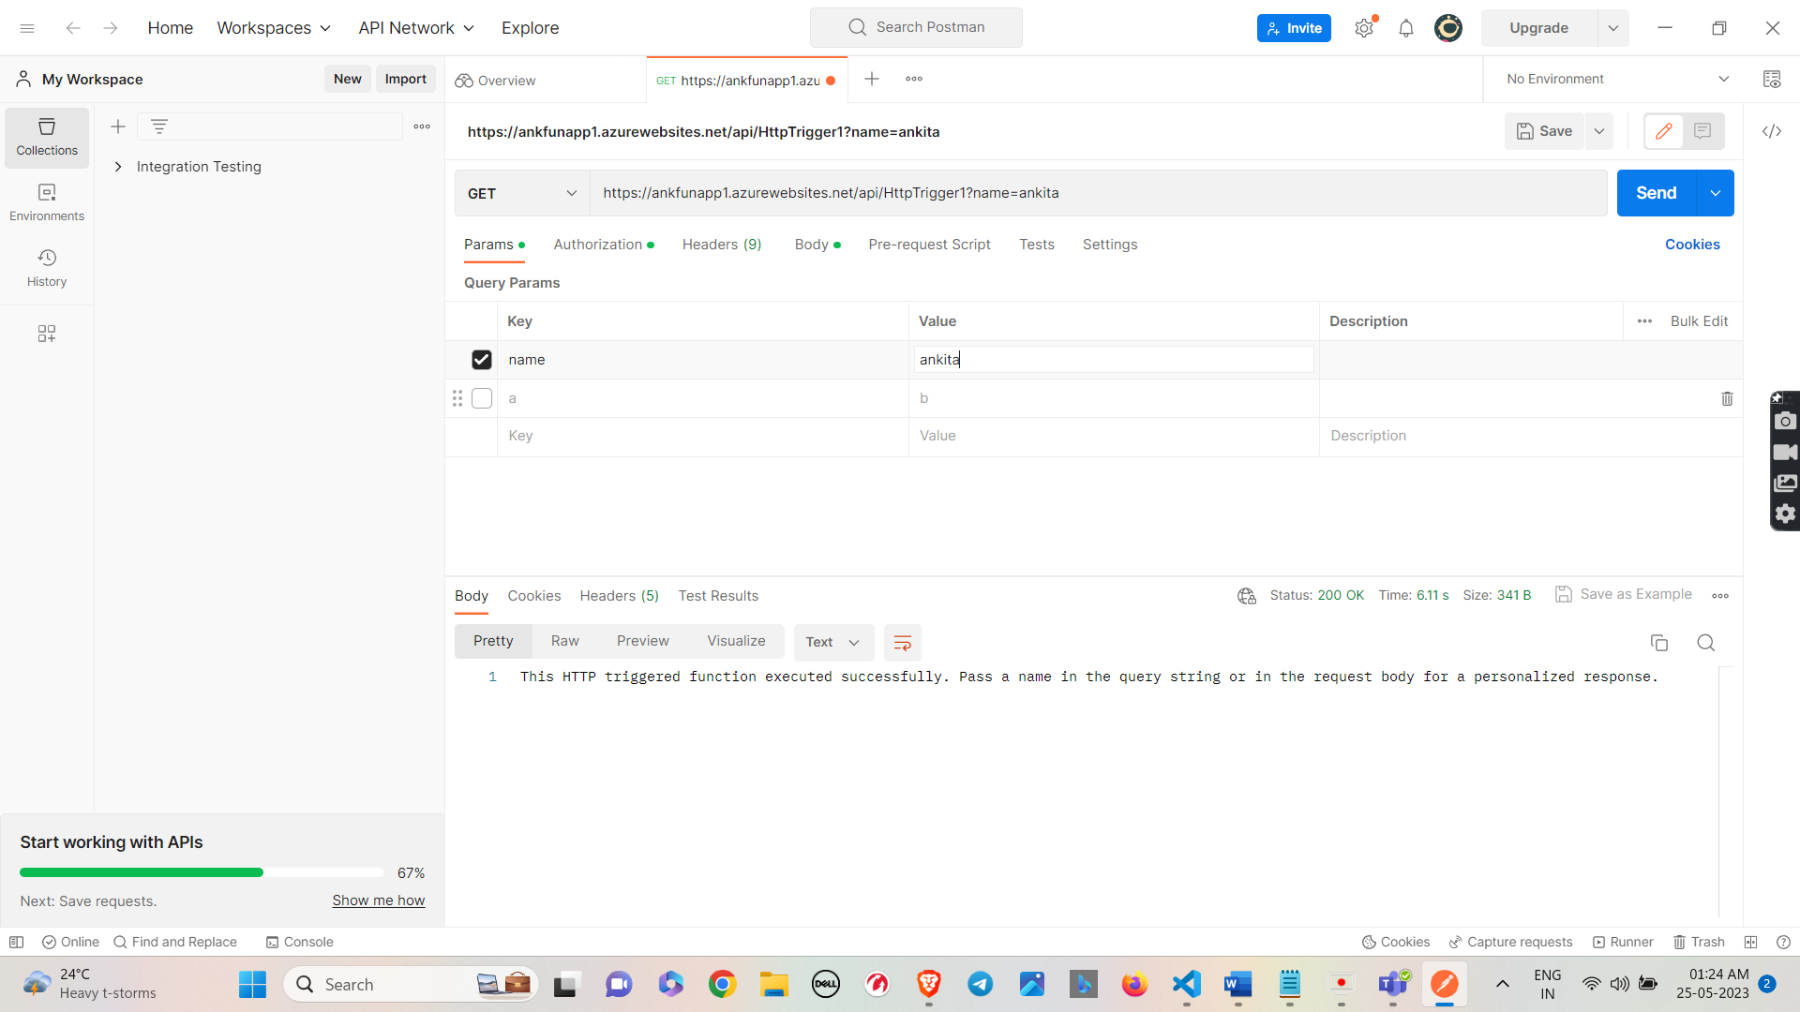

* Now name provide by you is displayed inside the trigger message.

